**FUNCTIONAL AND TECHNICAL COMBINED DOCUMENTATION**

**Page (38): Sign Up (Front End Url:** <http://localhost:8100/page38/page38>)

**Functional Picture:**

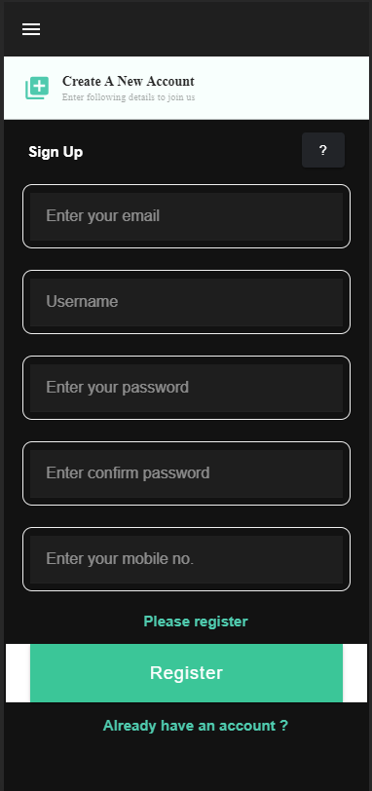

**Technical Explanation (Front End):**

**In Page38.tsx, we are calling following one API:**

1. UserCreate: see view.py python file from BackEnd

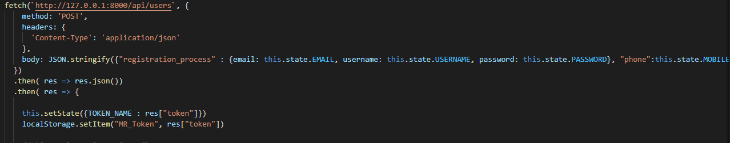

**As you can see above, there is one url:**

* [**http://127.0.0.1:8000/api/**](http://127.0.0.1:8000/api/)**users --🡪** UserCreate

**In** UserCreate API, we are doing a “POST” request for email, username and password with the help of “UserSerializer”. While doing the post request for Sign Up, we are also saving the phone Number in “UserProfile” model with the user_id.

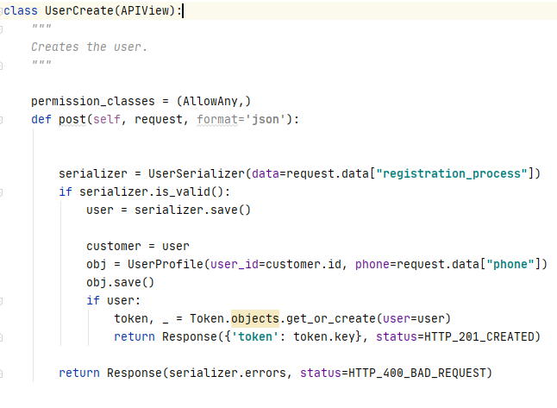

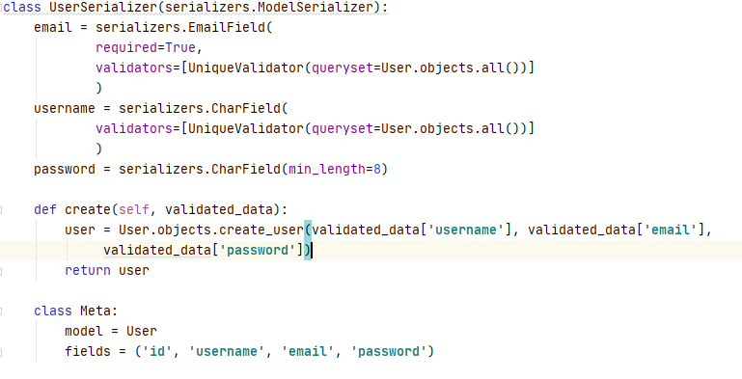

After the successful registration, the unique token will be generated for that user which will be used in OTP verification and throughout the application functionality with the help of localStorage() function.

Look at the response of the API call below:

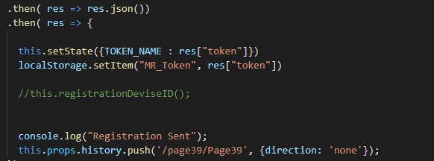

DONE !!!!